1. Create a P-T-S VPN and attach a VM to it

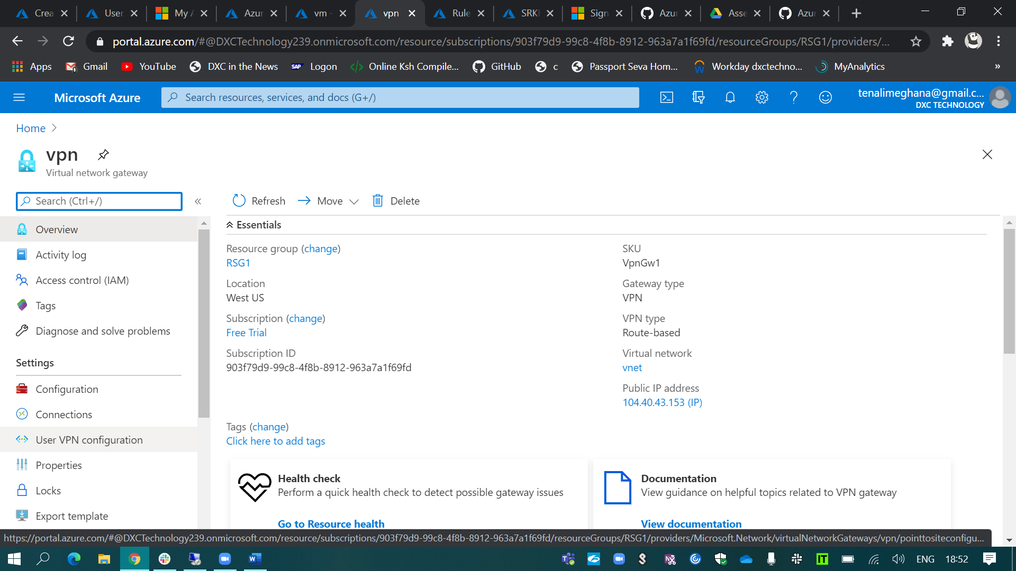

To create a point to site VPN for my virtual network which is in west US Location.

(i). First, I’ve created a gateway subnet.

(ii). And I’ve created the VPN in the same virtual network.

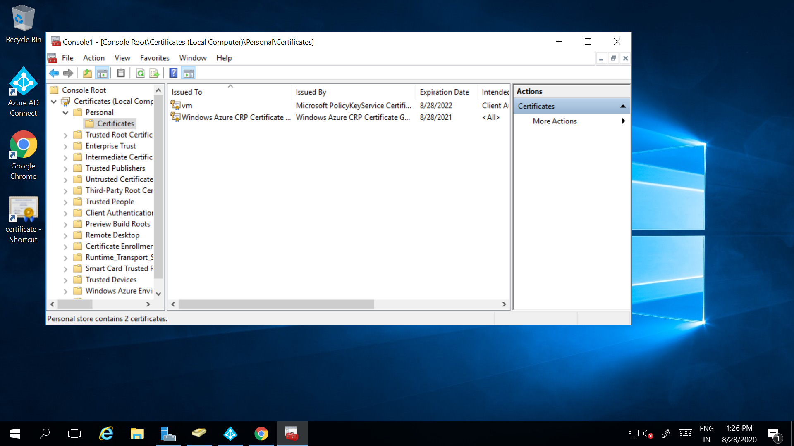

By using the Windows PowerShell ISE I’ve generated the client & root certificates for the User VPN configuration.

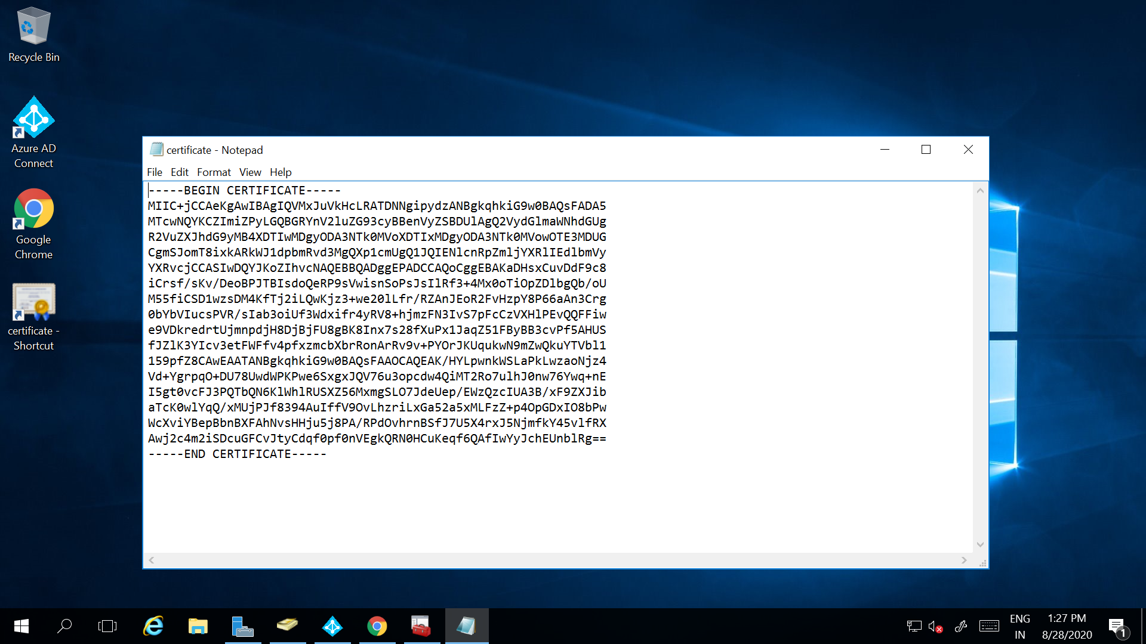

And I’ve exported the root certificate into the azure portal by copying the key.

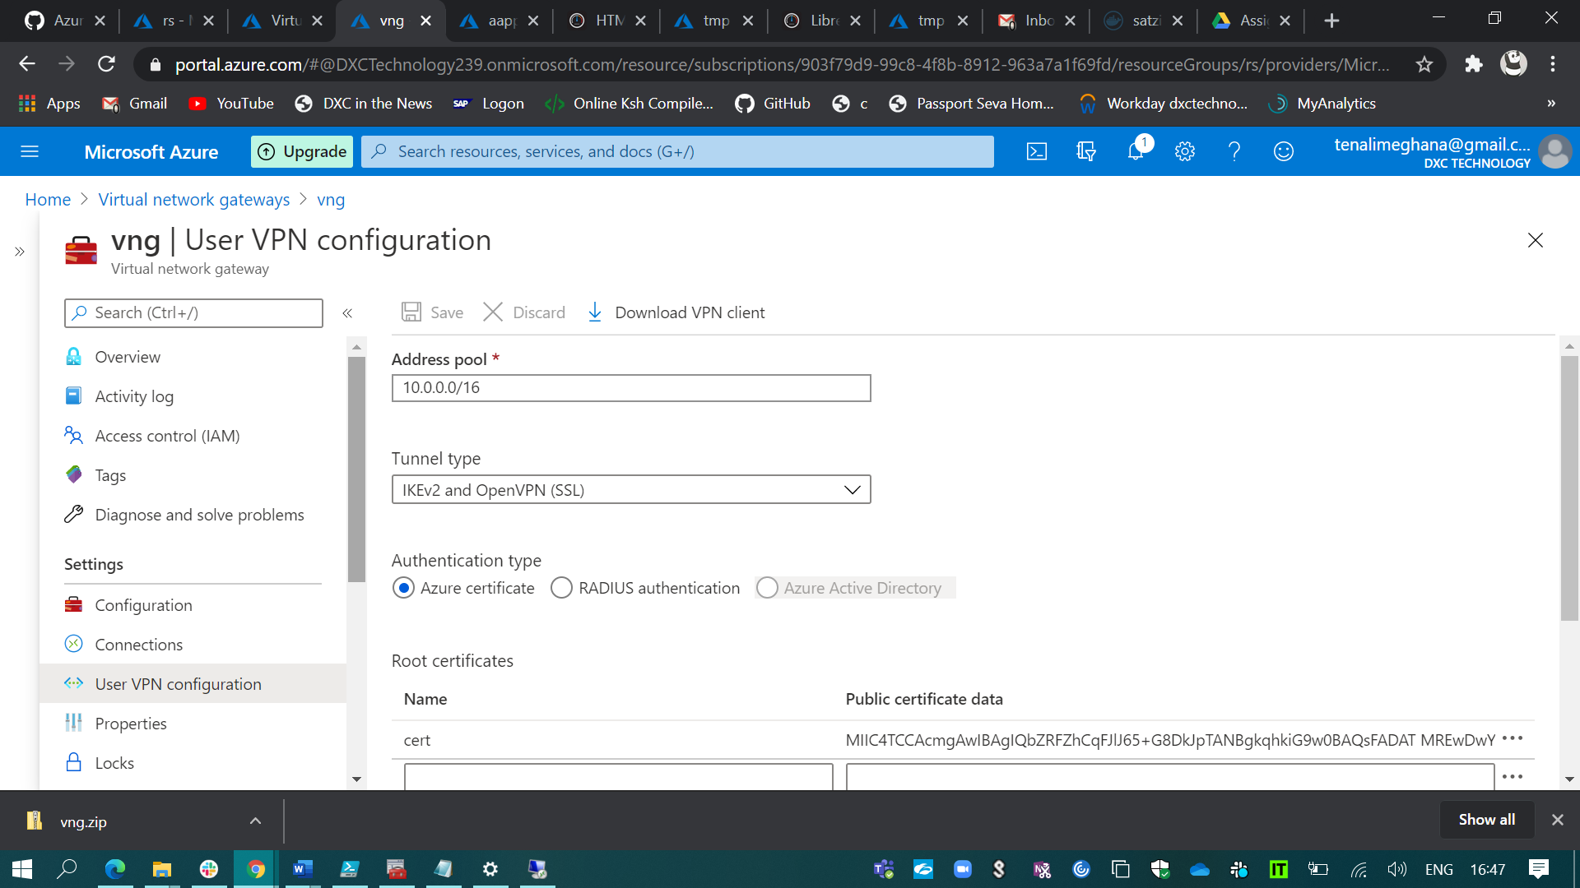

And user VPN has been created and before connecting to the VPN we have to download the VPN client in our PC.

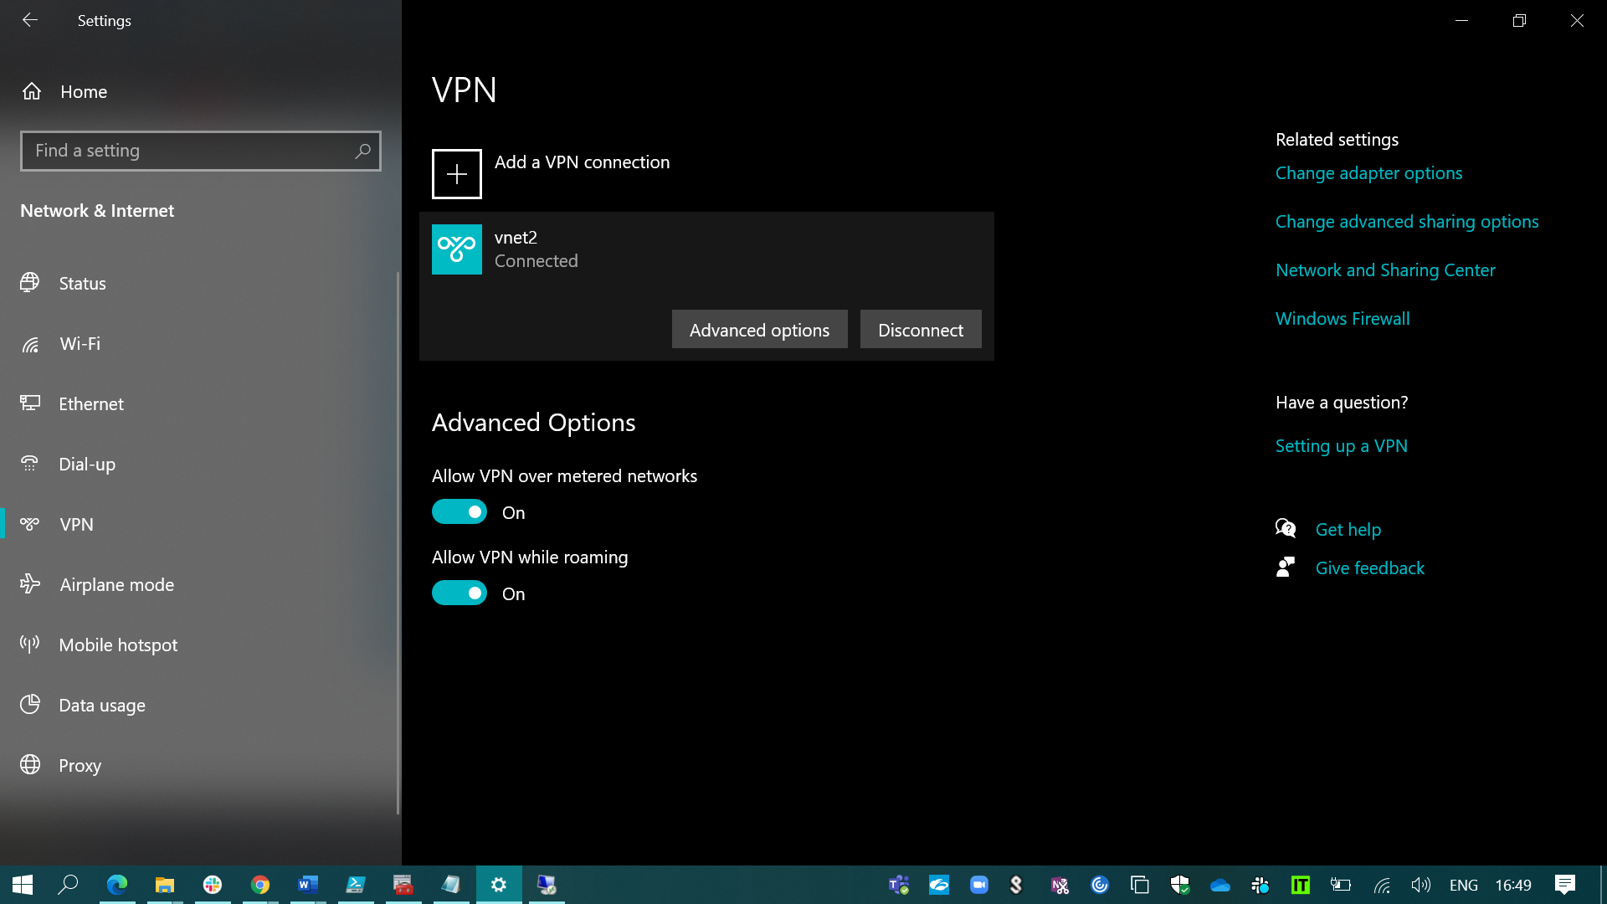

And then connect to the VPN & opened the VM with the help of its private IP which is connected to my virtual network vnet2 without any blockers.

1. create a two-web application in west us and central Us then attach to the traffic manager with Priority routing method.

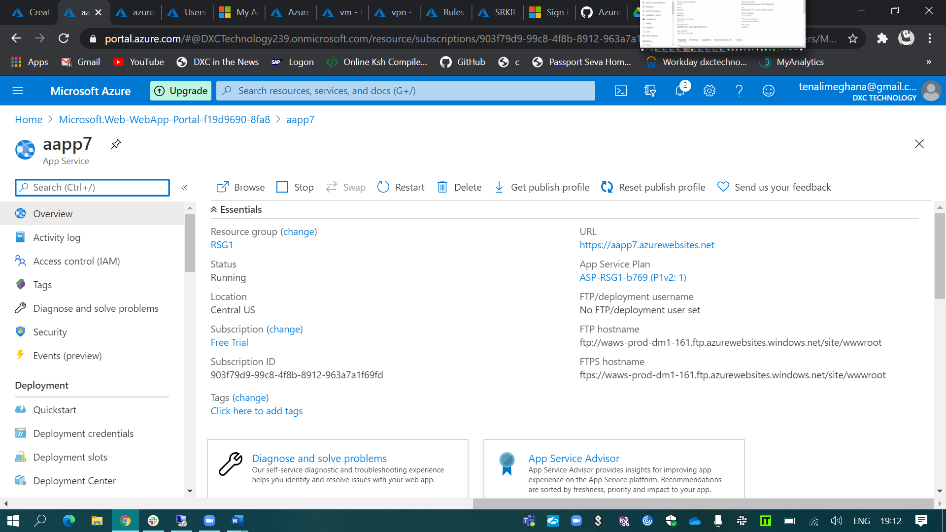

(i). Created the two web applications.

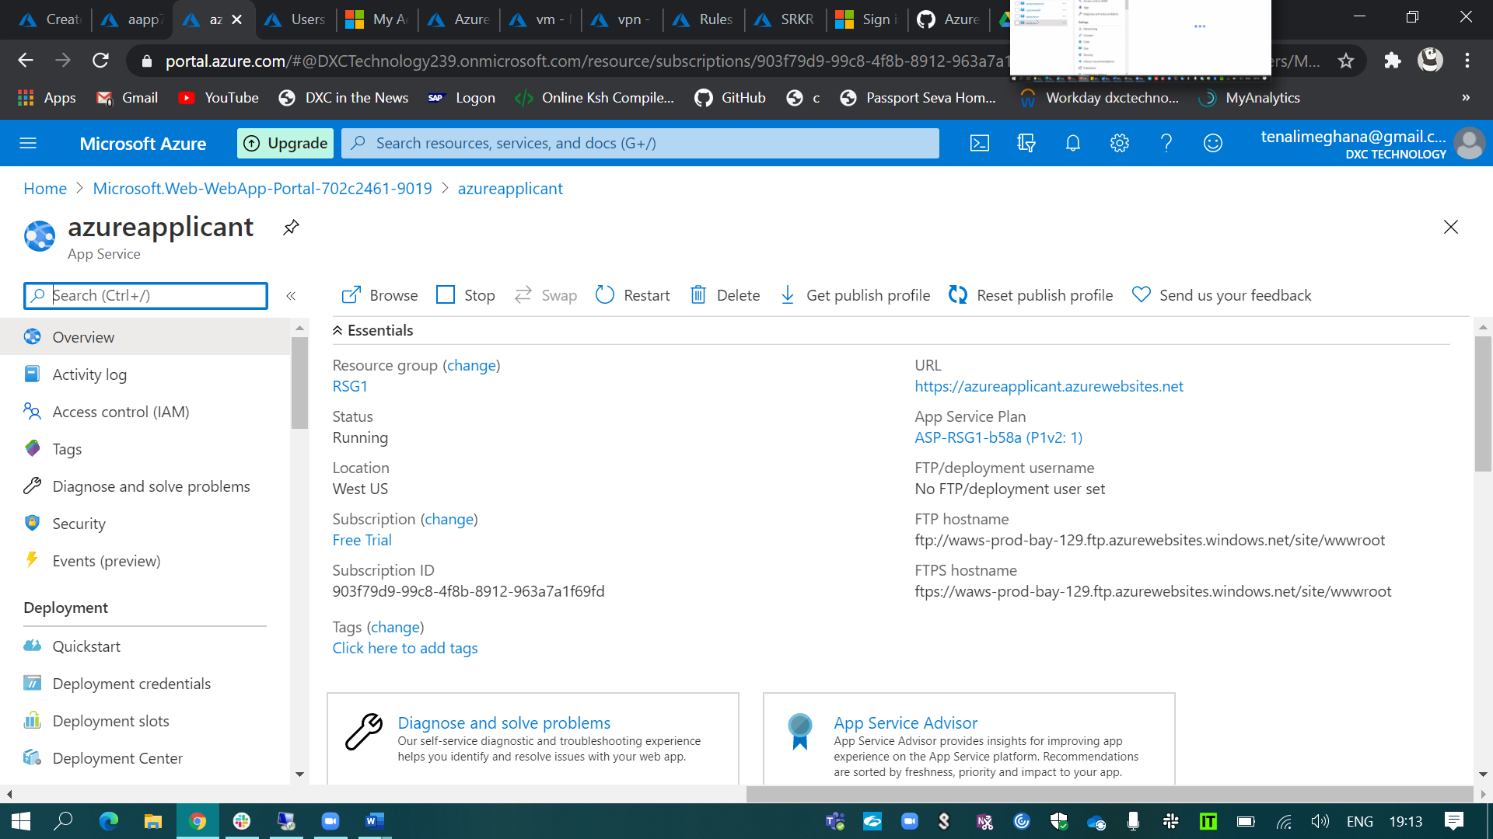

And kept those two web applications in the traffic manager profile which has been created using priority routing method.

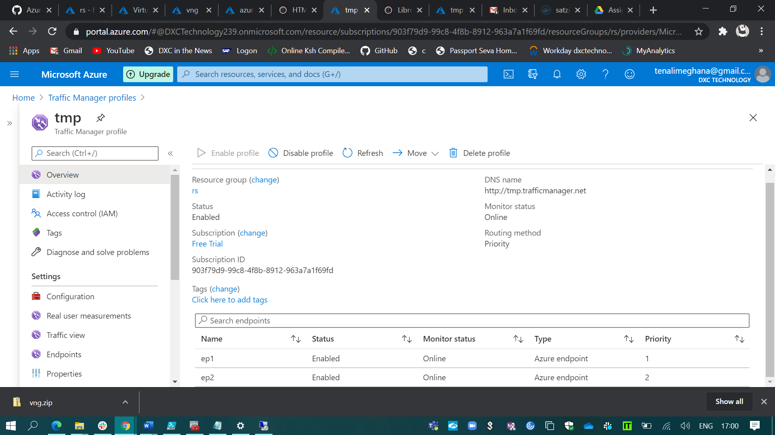

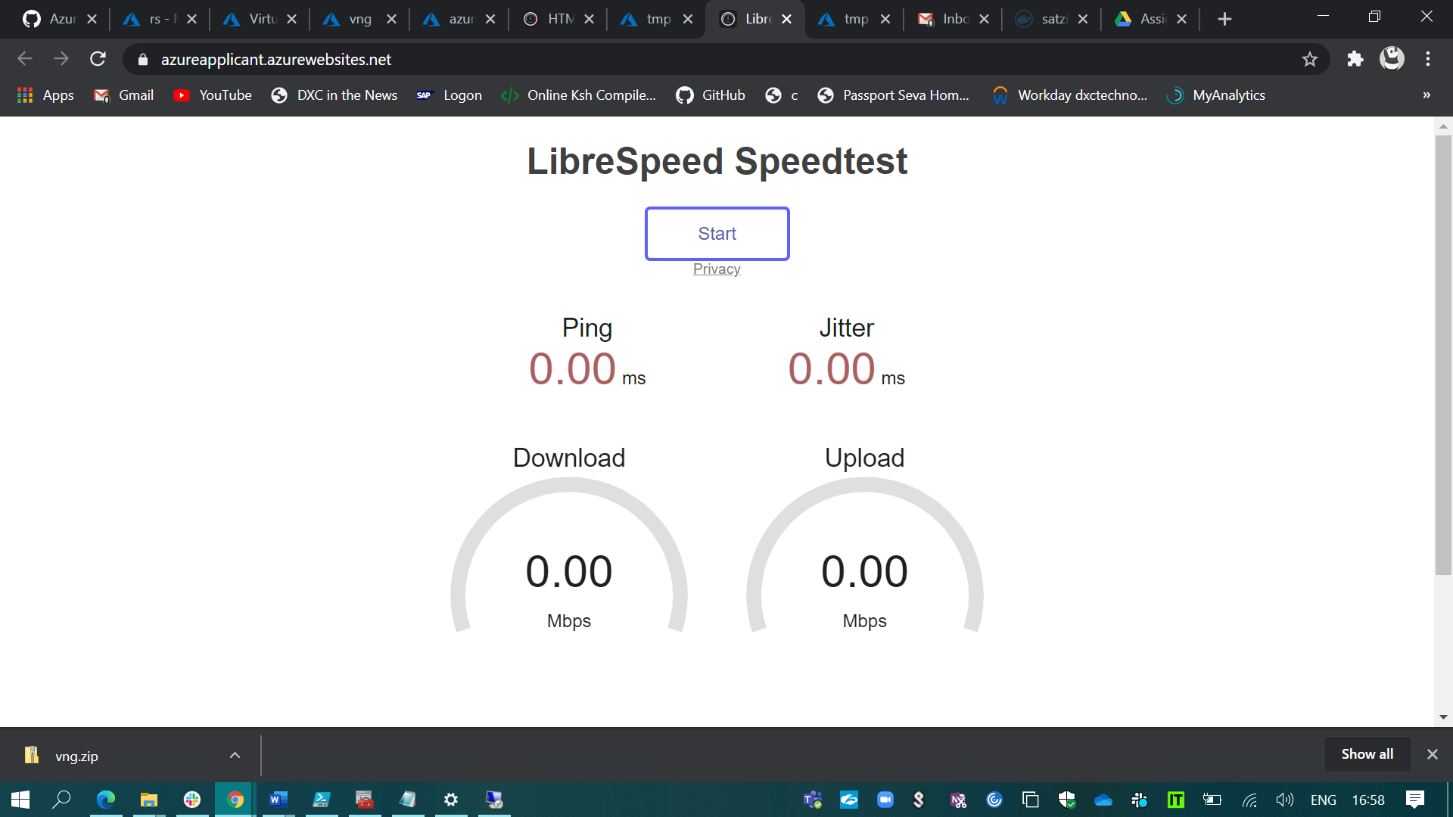

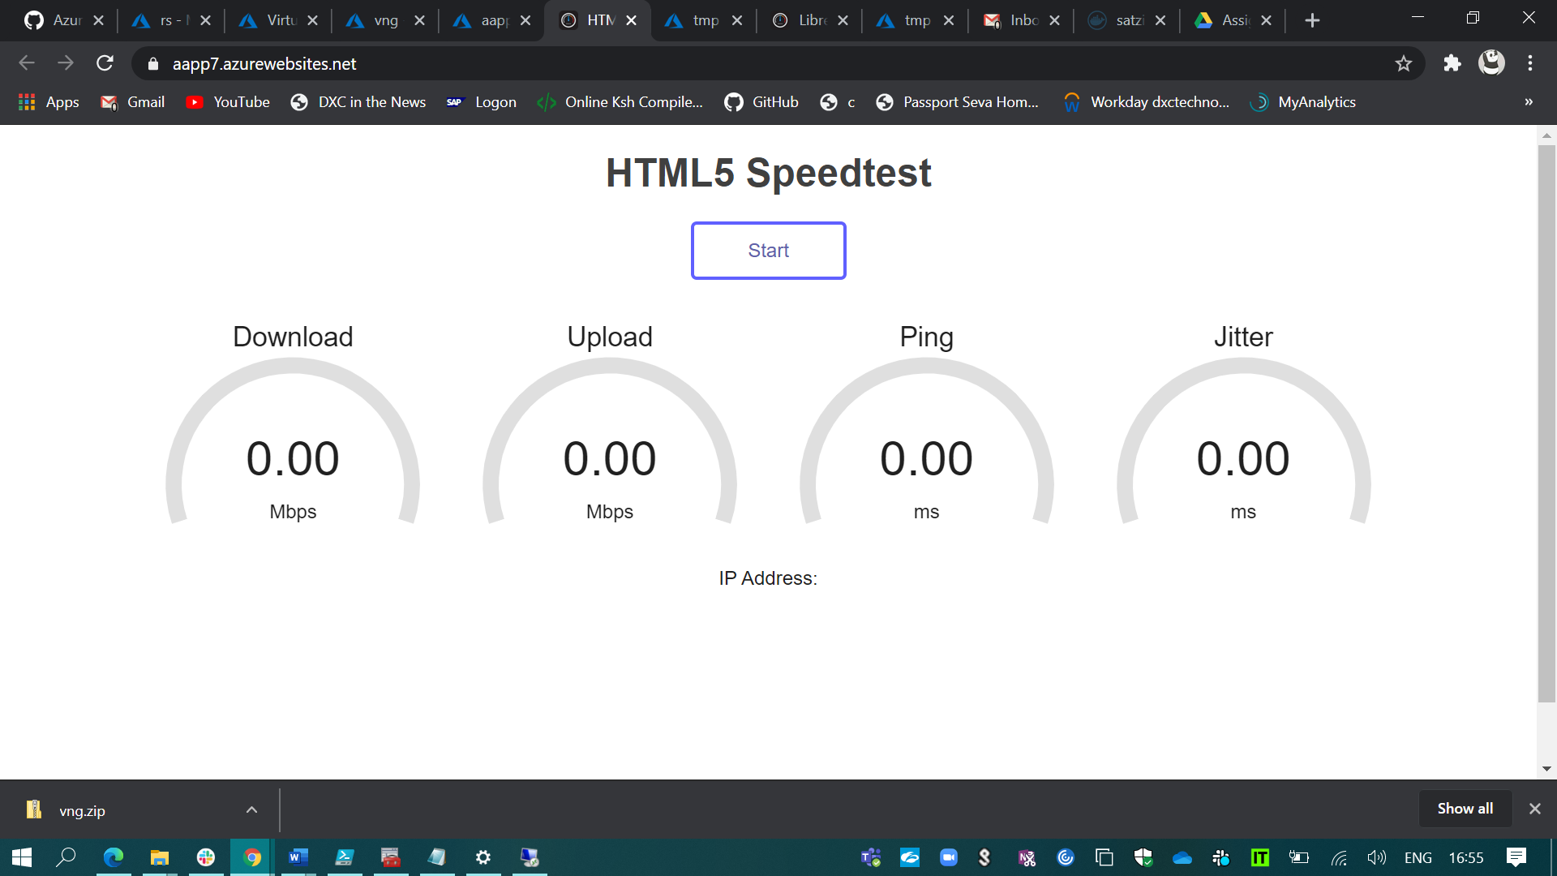

1. Create a windows server with AD installed and integrate with Azure AD.

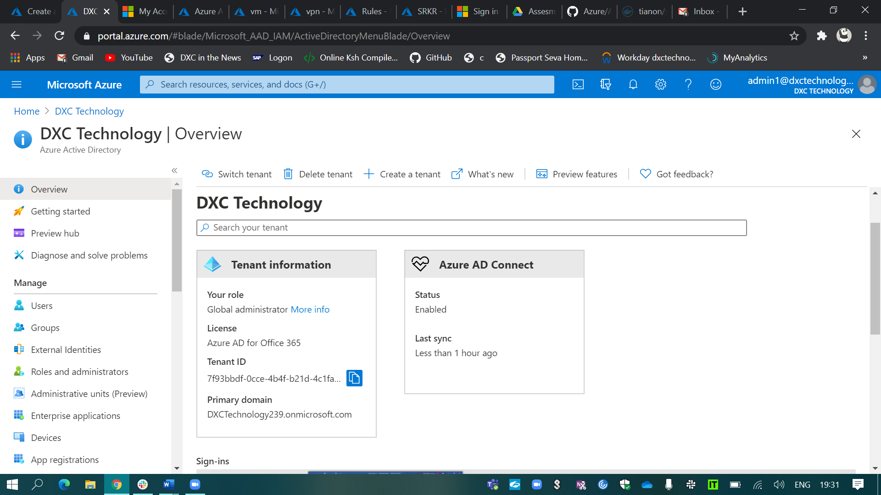

I integrated my windows Active directory server to Azure AD.

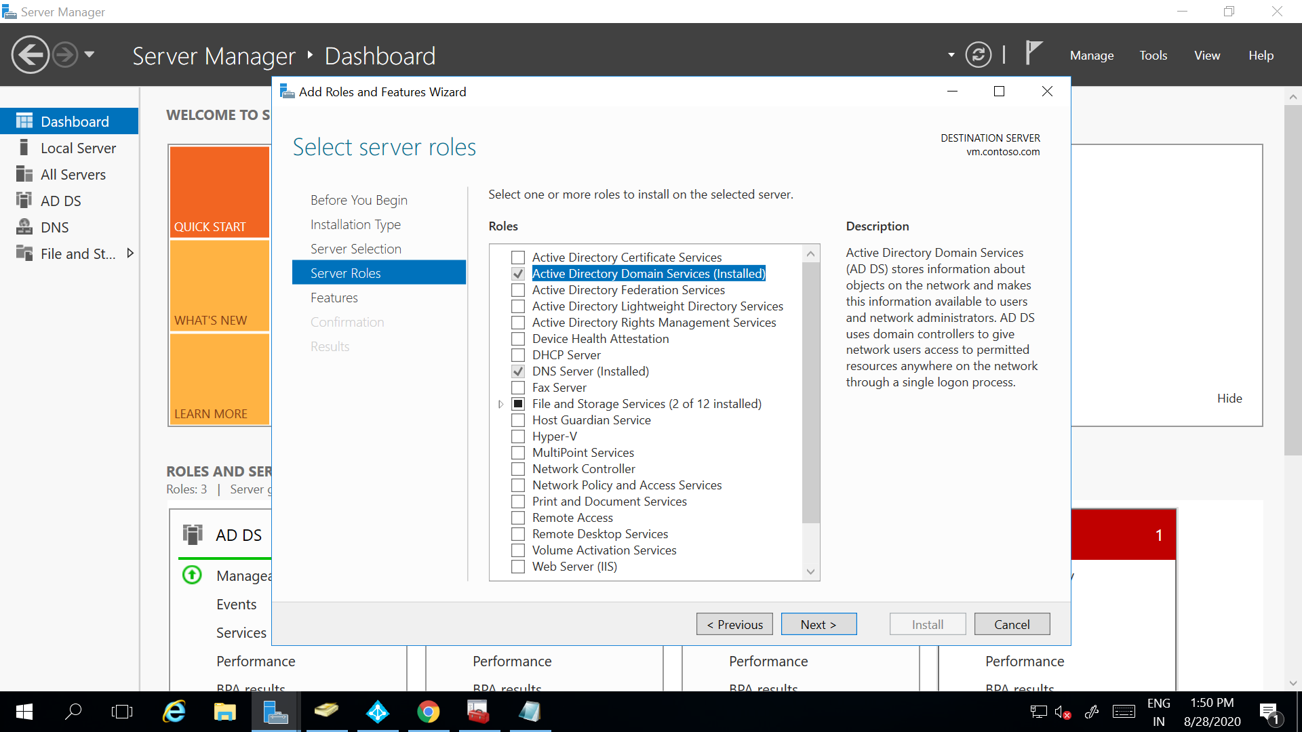

I configure my windows AD server.

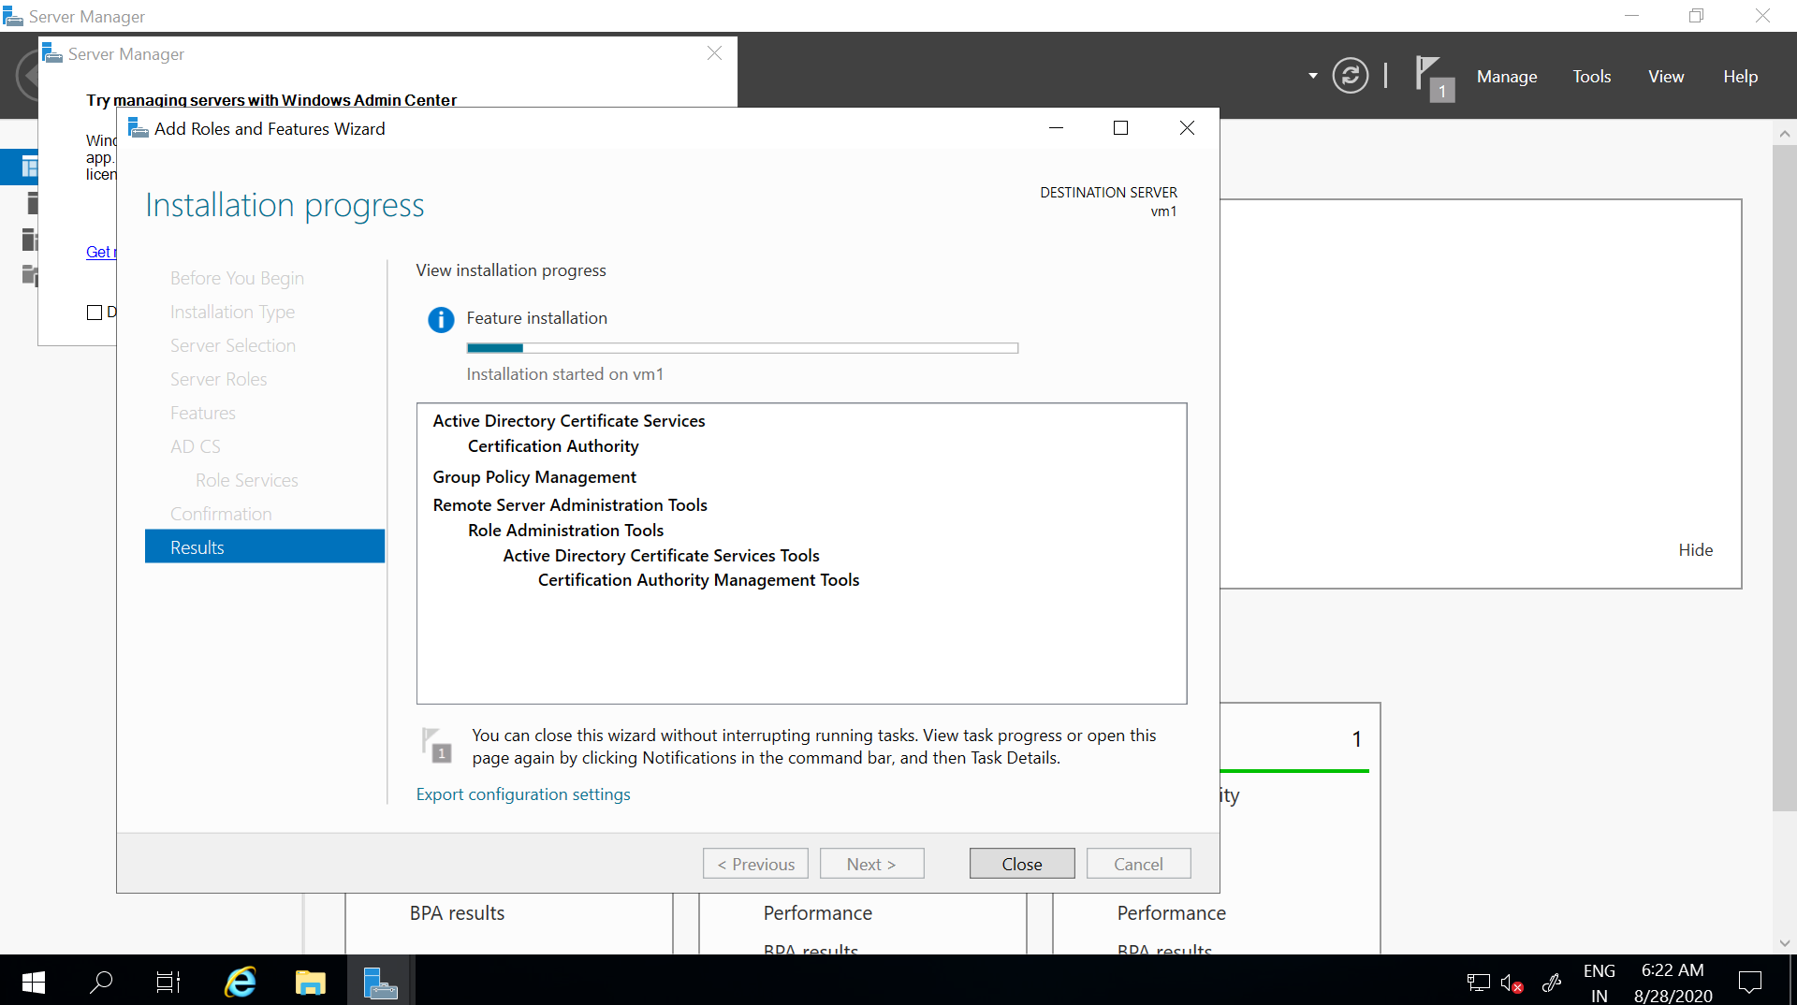

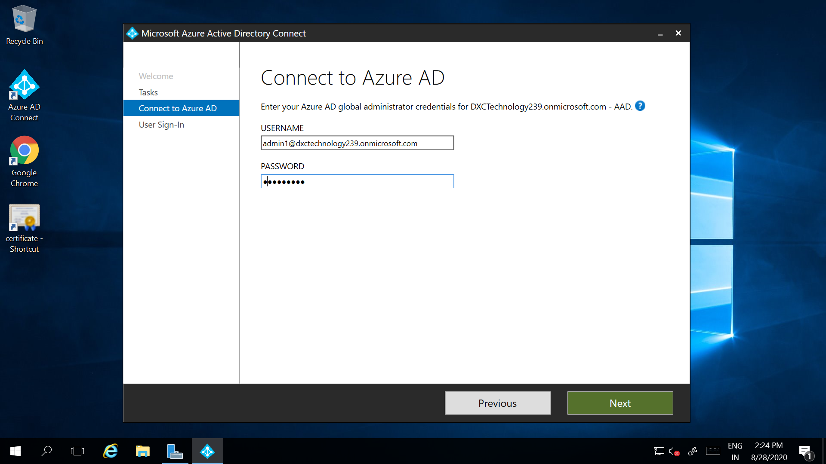

For identification purpose I’ve created a user in my AD users.

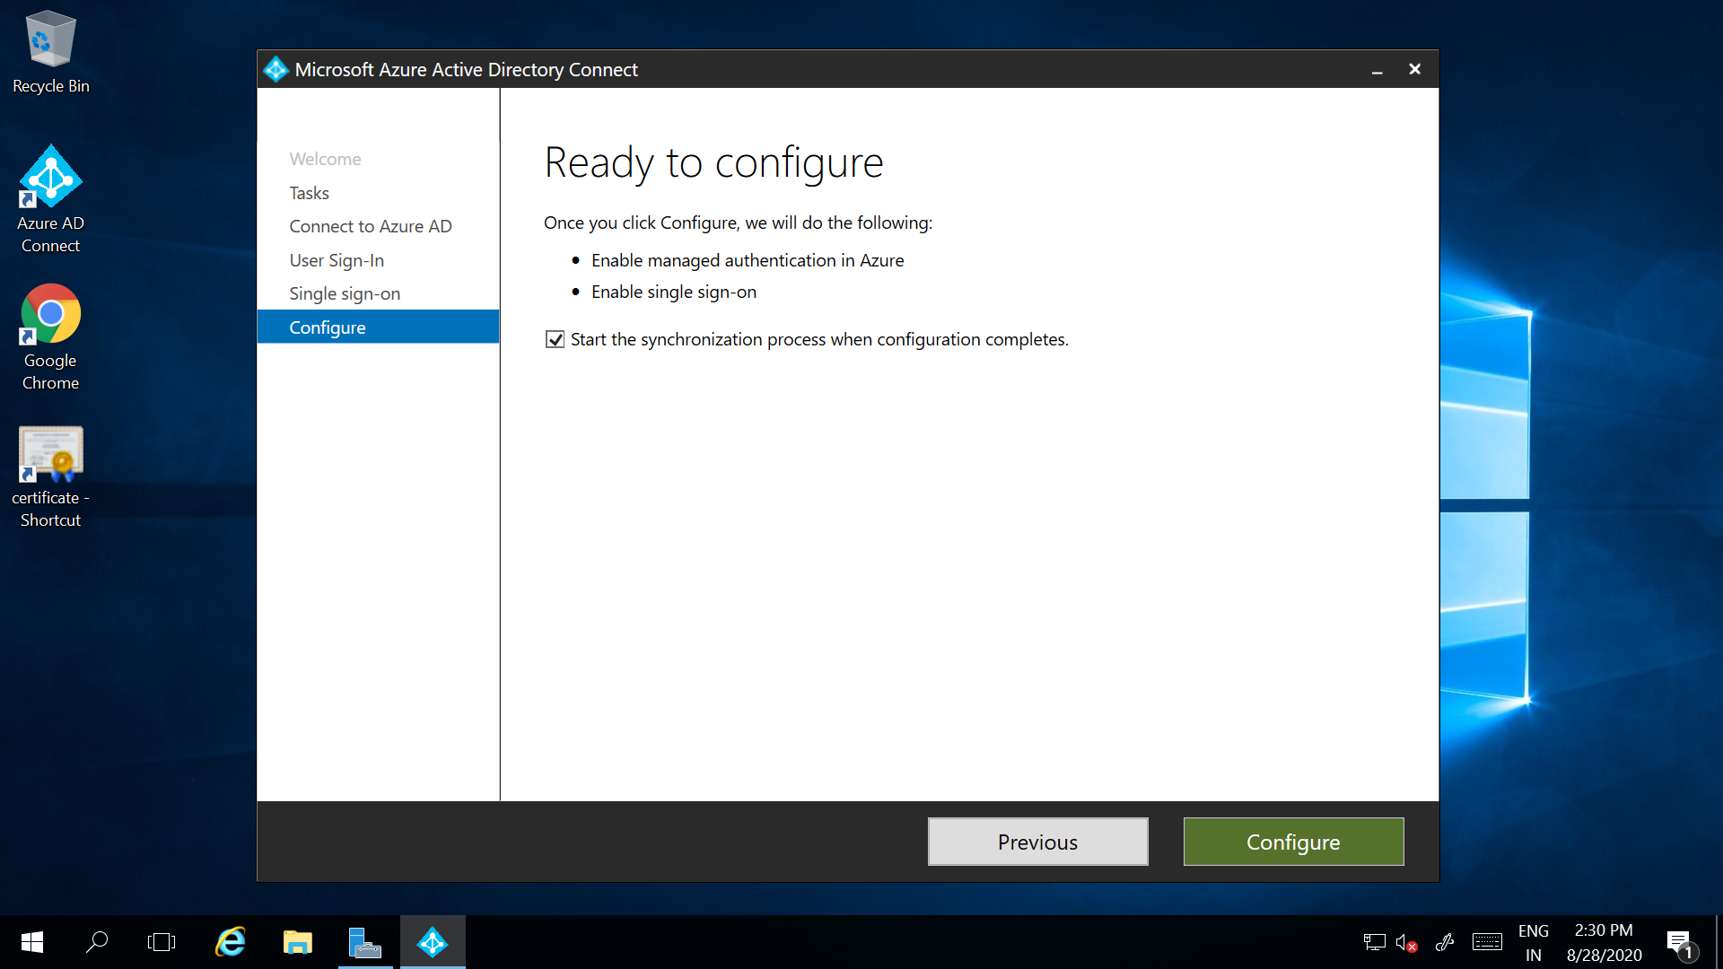

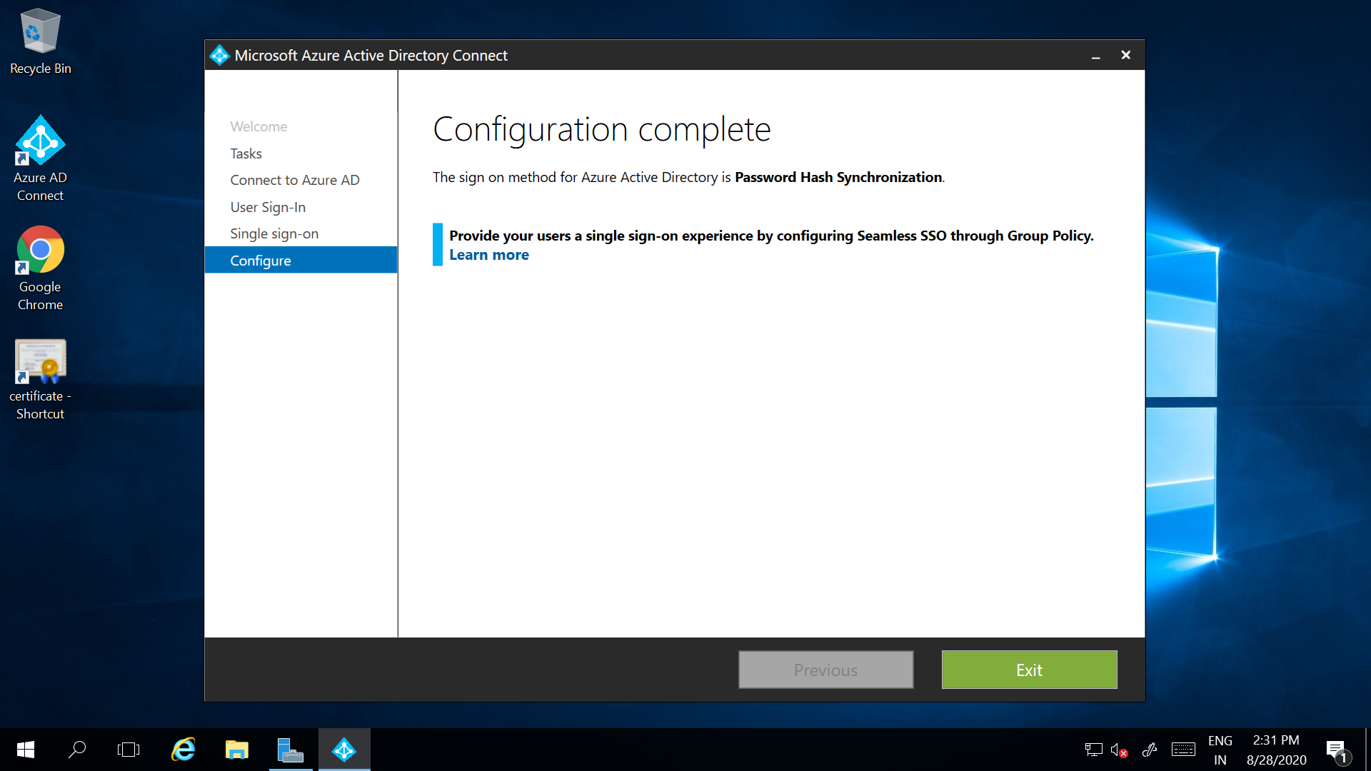

And after the completion of my configuration. We’ll check the users in the portal.

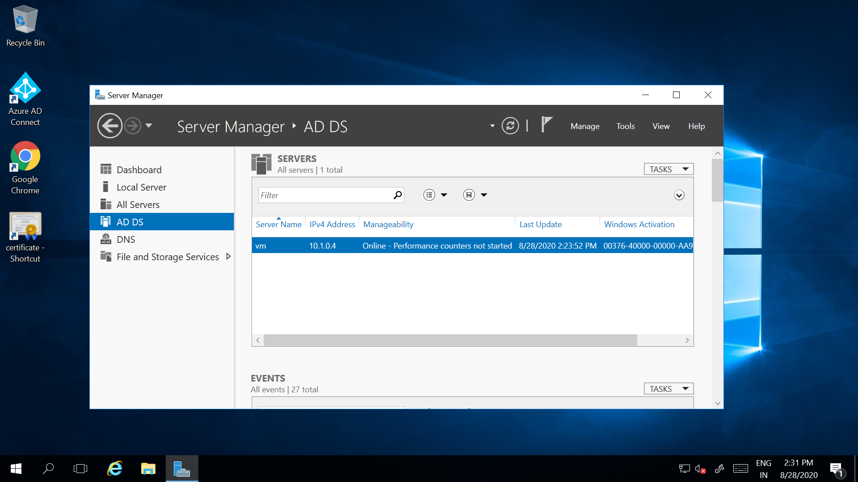

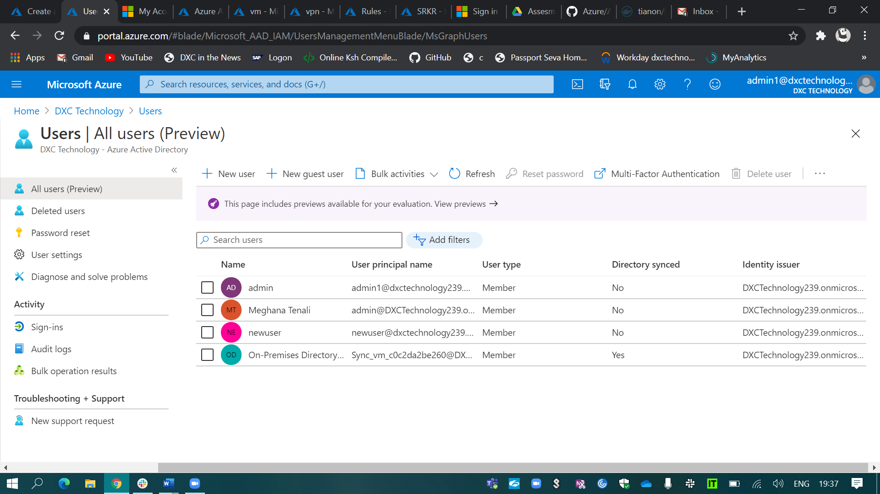And finally, the user has been added to the AD.

1. configure a backup to the VM you installed AD.

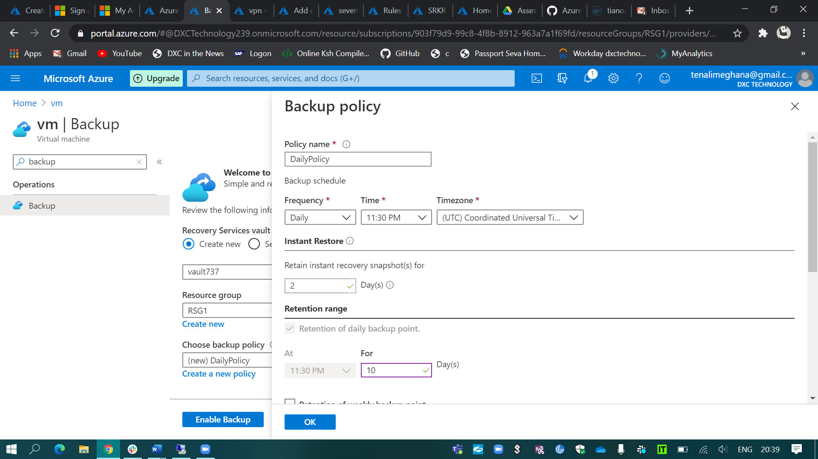

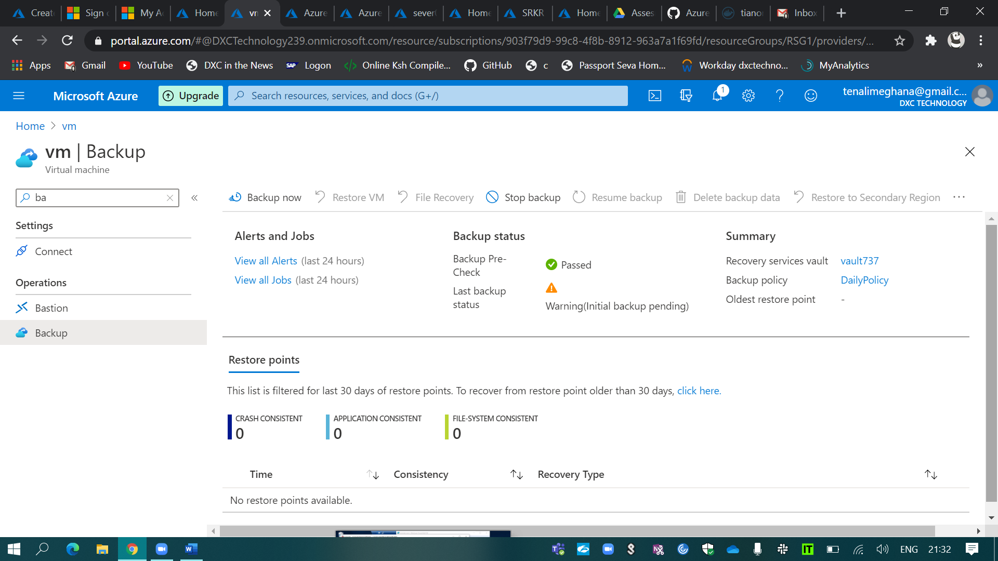

1. configure alerts for the VM

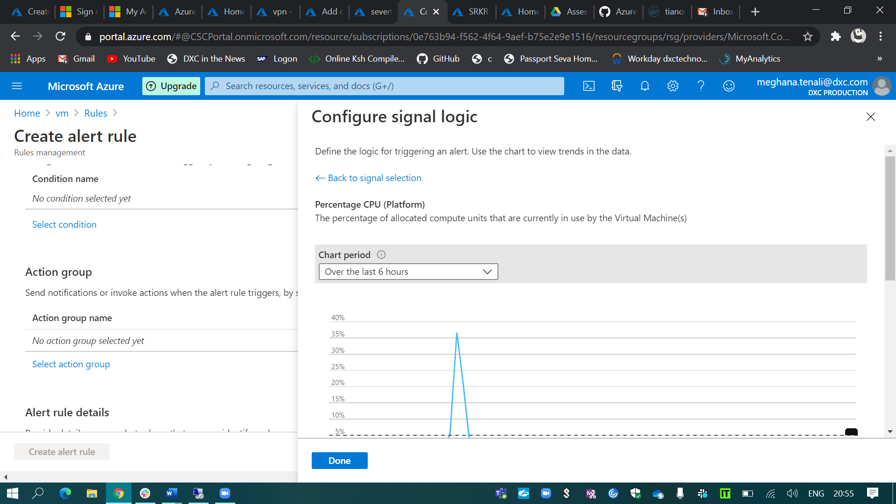

I’ve created the alert rule for the CPU threshold and it should be greater than 5%. 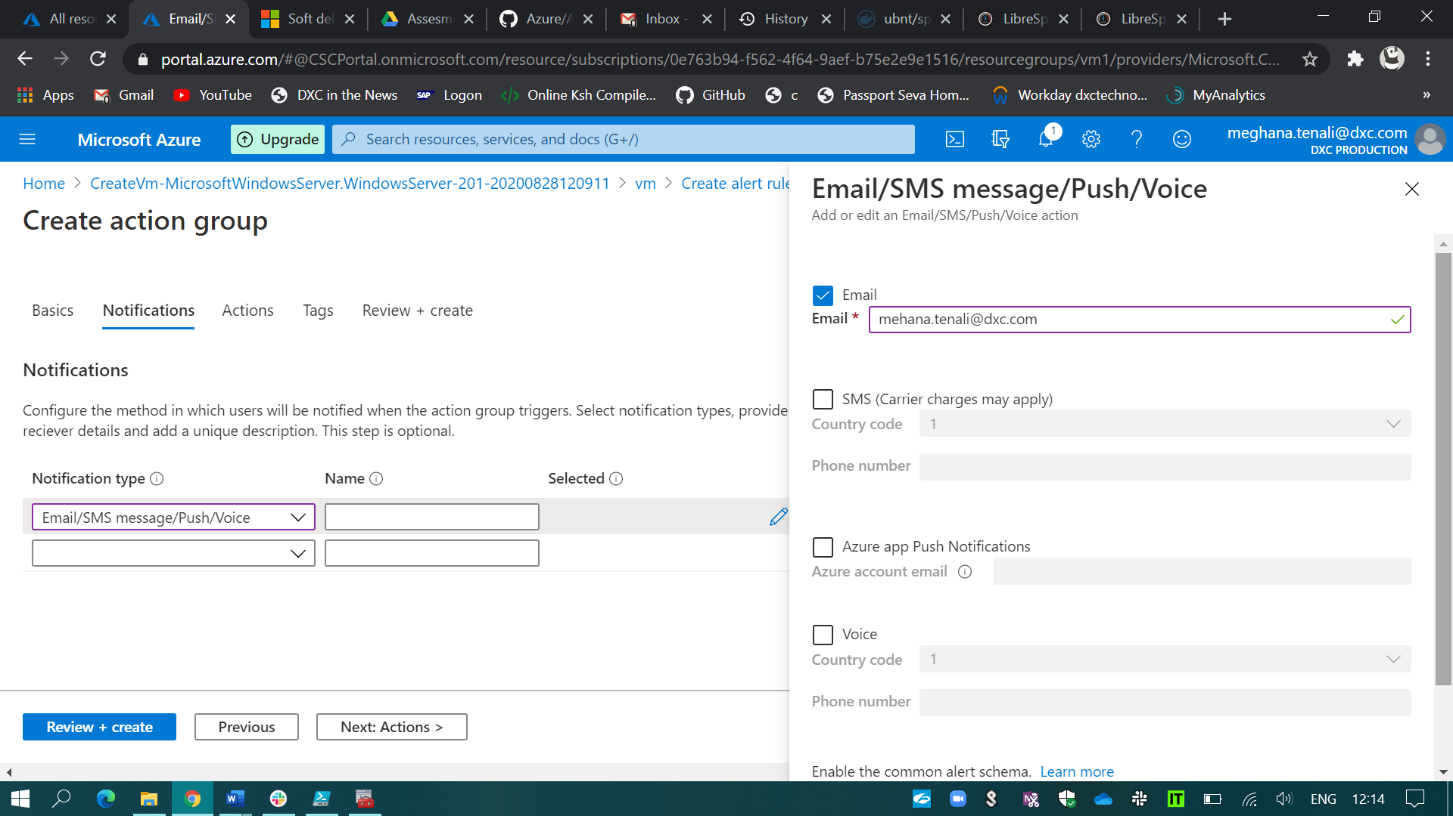

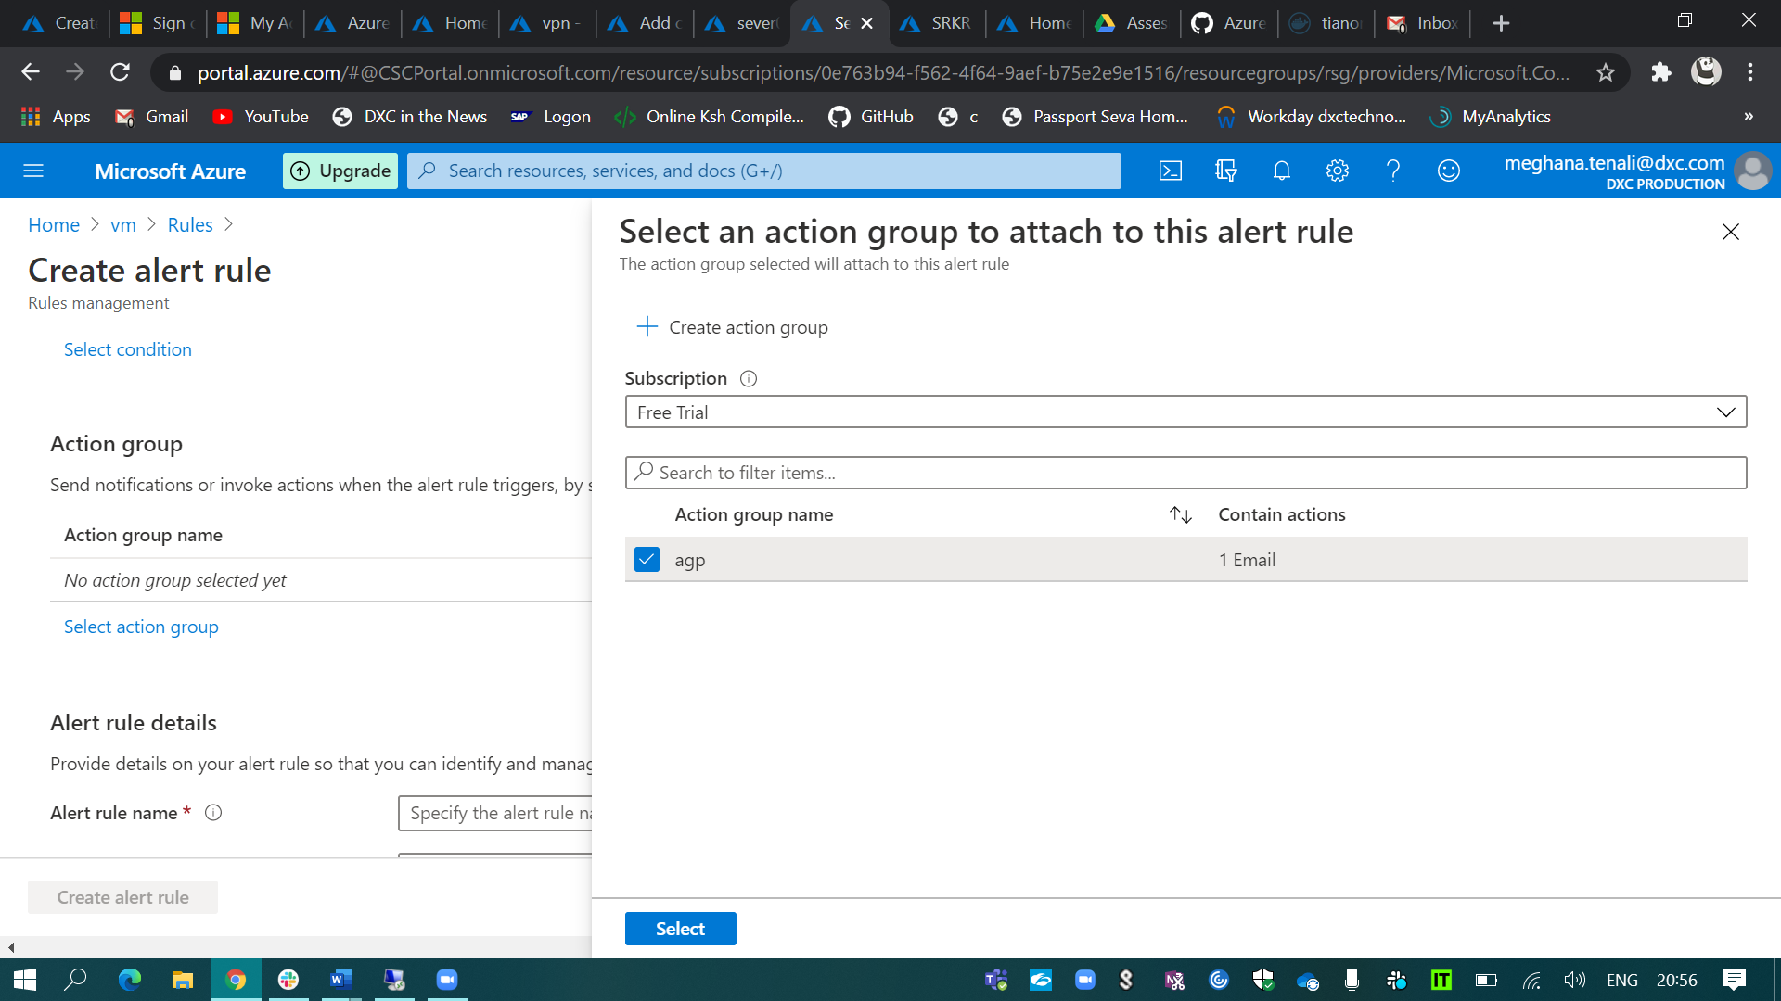

And I’ve created the alert rule and enabled it.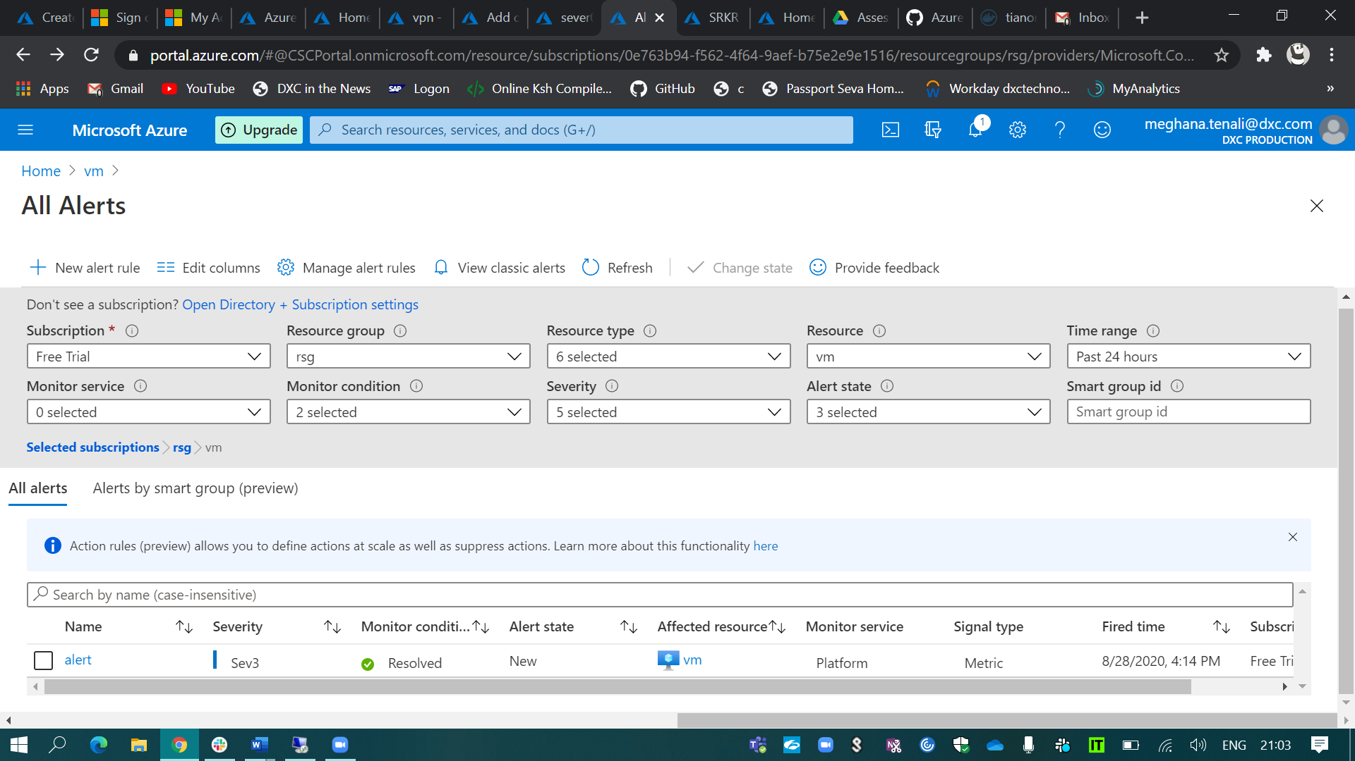

1. Apply any security policy to the subscription.

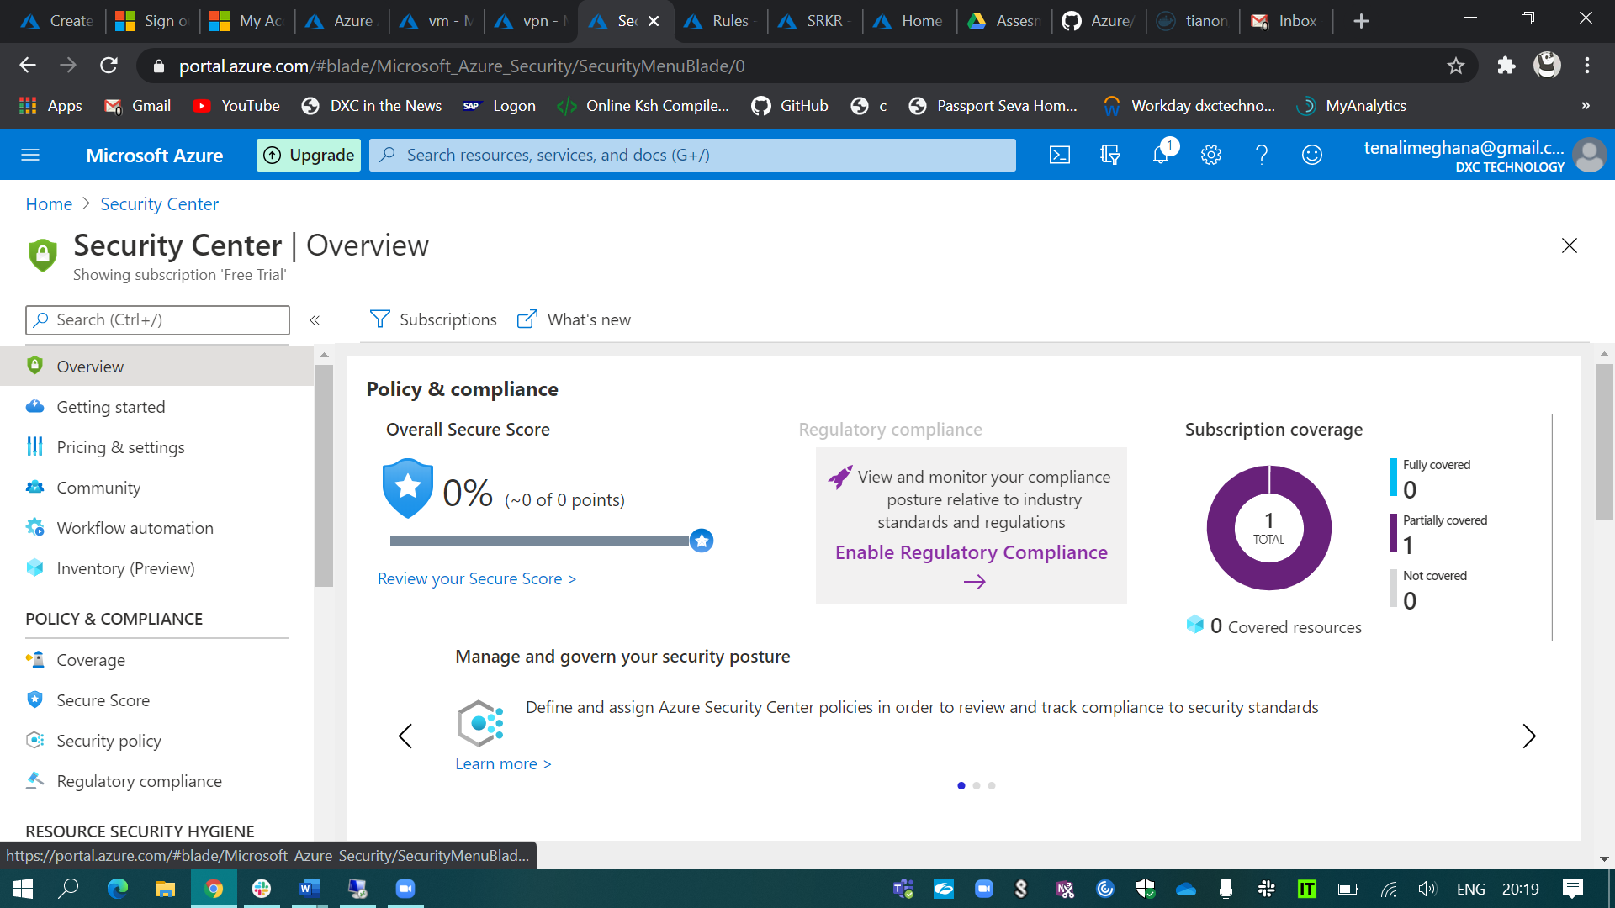

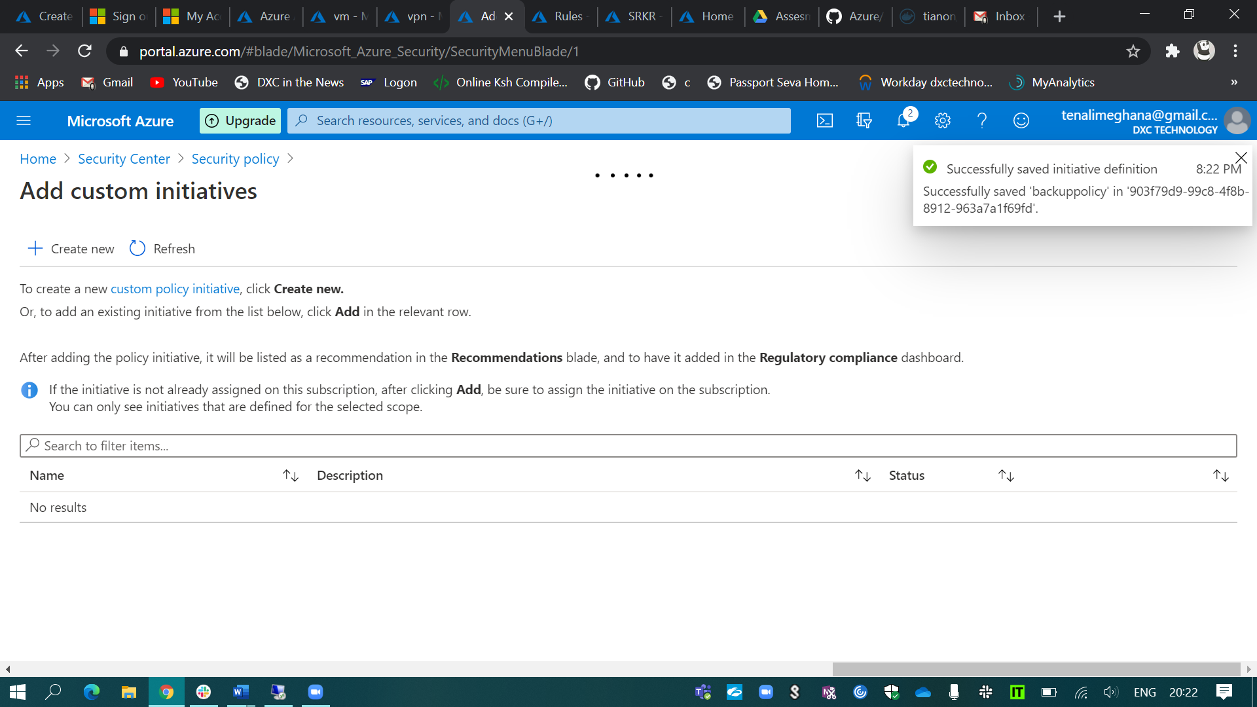

Azure backup has enabled for my VM in the security alert.

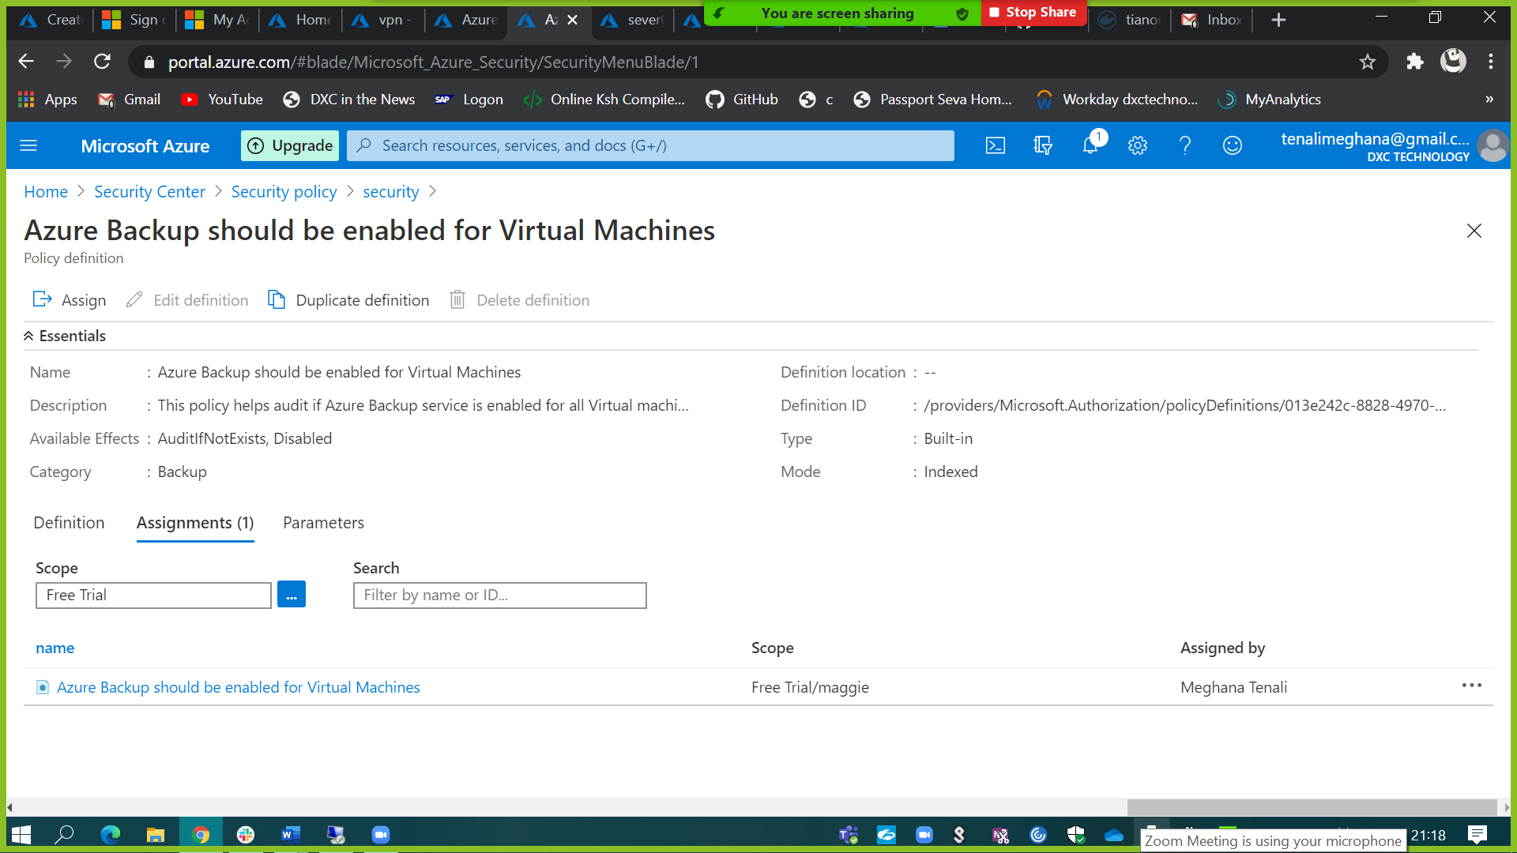

1. Create a SQL server with database installed in the elastic pool.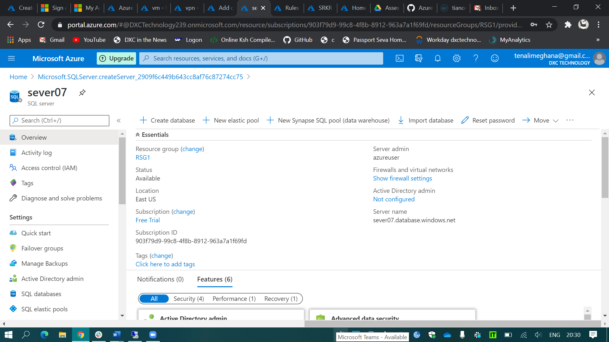

I created a SQL database with elastic pool.

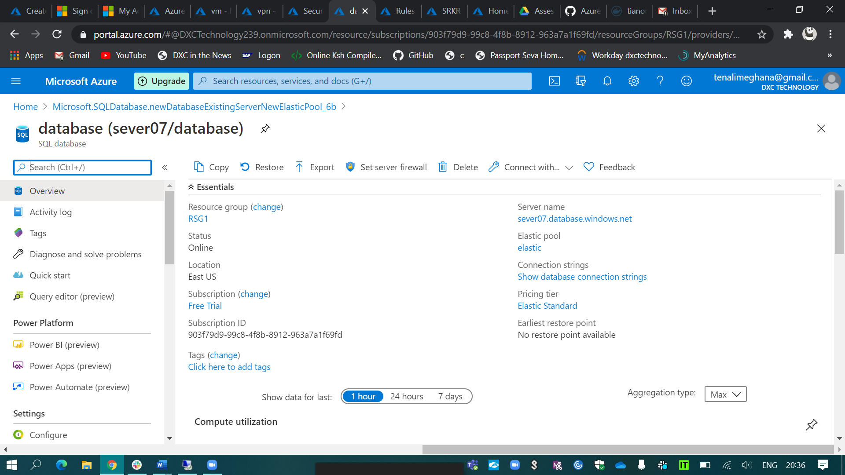

It is the database that I created using elastic pool.

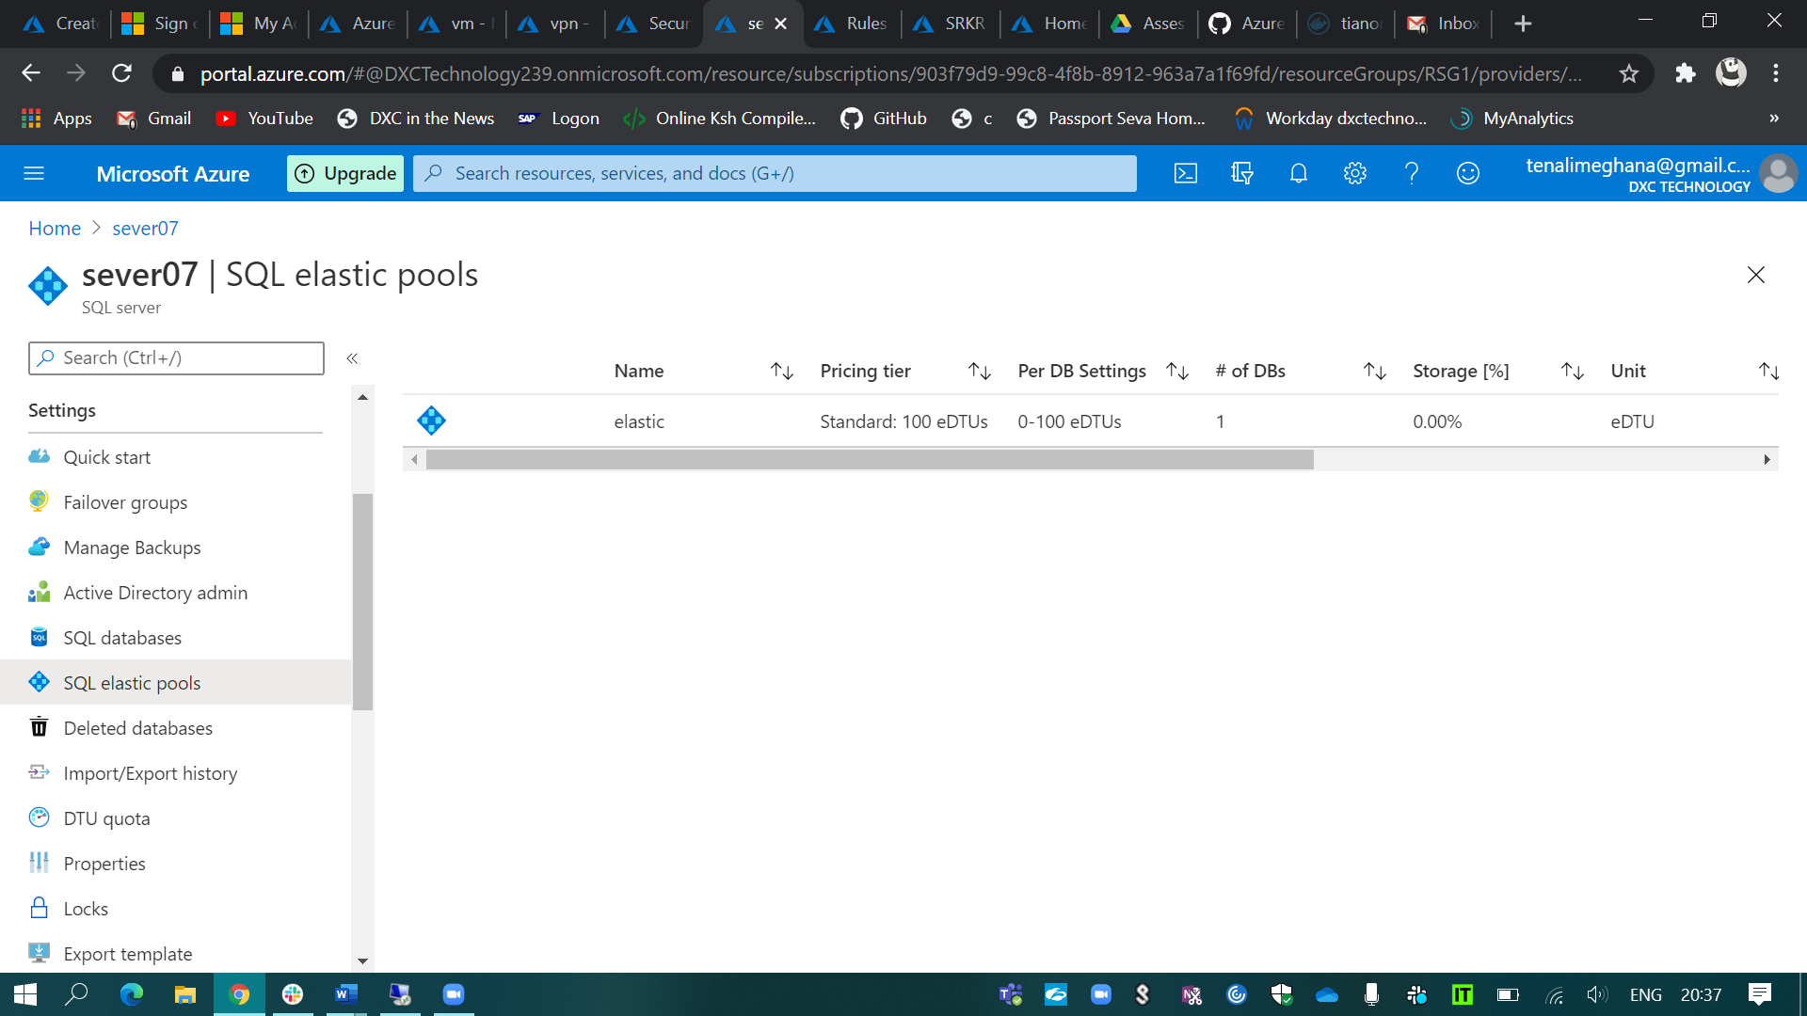

Here, it shows the elastic pool that I’ve created.